POISSON’S EQUATION:
INTRODUCTION:
An equation of the form ∇²u = f(x,y)
(1.e.,) 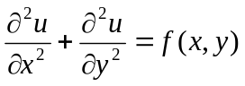 -------------(1)
is called as POISSON’S equation where f(x,y) is a function of x and y only.
We will solve the above equation numerically at the points of the square mesh, replacing the derivatives by difference quotients. Taking x = ih, y = jk = jh the differential equation reduces to
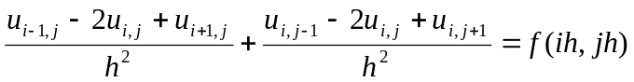
i.e., ------------(2)
By applying the above formula at each mesh point, we get a system of linear equation in the pivotal values i , j.
PROBLEM:
- Solve ∇²u = -10(x²+y²+10) over the square mesh with sides x = 0, y = 0, x = 3, y = 3, with u = 0 on the boundary and mesh length 1 unit.
Sol

A u = 0 B
D u₁ E u₂
u = 0 u = 0
F u₃ G u₄
O C
u = 0

The P.D.E is ∇²u = -10(x²+y²+10) s --------(1)
Using the theory, (here h =1)
--------(2)
Applying the formula (2) at D,( i = 1, j = 2)
0 + 0 + u₂ + u₃ -4u₁ = -10(15) = -150
u₂ + u₃ -4u₁ = -150 --------(3)
Applying (2) at E, ( i = 2, j = 2)
u₁ + u₄ -4u₂ = -180 --------(4)
Applying (2) at F,( i = 1, j = 1)
u₁ + u₄ -4u₃ = -120 --------(5)
Applying (2) at G,( i = 2, j = 1)
u₂ + u₃ -4u₄ = -150 --------(6)
We can solve the equation (3), (4), (5), (6) either by direct elimination or by Gauss-Seidel method.
The values are,
u₁ = u₄ = 75, u₂ = 82.5, u₃ = 67.5

